DRAFT Technical Memorandum |  | 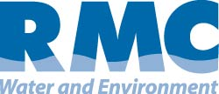

Merced Integrated Regional Water Management Plan
Subject: | Land Use Planning Technical Memorandum
Prepared For: | Merced Integrated Regional Water Management Plan – Regional Advisory Committee
Prepared by: | RMC Water and Environment
Date: | June 11, 2012
Contents
1 Relation to Local Land Use Planning 2
1.1 Linkages Between Water Management and Land Use Planning 3
1.2 Current Relationships Between Water Managers and Land Use Planners 5
1.3 Future Efforts to Establish Proactive Relationships 5
2 References 7

The Merced Region is undertaking development of an Integrated Regional Water Management (IRWM) Plan. This effort was initiated by the Merced Area Groundwater Pool Interests (MAGPI), which currently serves as an interim Regional Water Management Group (RWMG) responsible for developing the IRWM Plan. The Region has received a grant from the California Department of Water Resources (DWR) to prepare a plan that meets statewide IRWM Plan standards.
The purpose of this technical memorandum (TM) is to document the current relationship between local land use planning, regional water issues, and water management objectives and identify future plans to further a collaborative, proactive relationship between land use planners and water managers. This TM will serve as the basis for the Relation to Local Land Use Planning section of the MIRWMP.

Relation to Local Land Use Planning
Integrated Regional Water Management (IRWM) Plans must:
- Contain processes that foster communication between land use managers and RWMGs with the intent of effectively integrating water management and land use planning
- Document the current relationship between local land use planning, regional water issues, and water management objectives
- Identify future plans to further a collaborative, proactive relationship between land use planners and water managers.

The Merced Region appreciates the importance of fostering communication between land use managers and water resource managers to effectively integrate water management and land use planning. This section documents the current relationship between local land use planning, regional water issues, and water management objectives in the Merced Region. Additionally, future plans to foster a collaborative, proactive relationship between land use planners and water managers are identified.
California State Law requires every city and county in the state to prepare and maintain a General Plan. General Plans provide a blueprint for future decisions regarding land use and resource conservation. Land use agencies that prepare these plans are responsible for managing growth and development while ensuring a healthy and sustainable economy. In the Merced Region, entities with land use authority include:
- County of Merced
- City of Merced
- City of Livingston
- City of Atwater
Figure 1 shows the boundaries of these local land use agencies within the Merced Region. These agencies implement public outreach efforts to help define the local community’s vision for future growth and development. Stakeholders within the Merced Region are enthusiastic about the IRWM planning effort and the opportunity for more comprehensive land use considerations in developing future conceptual models for water management issues.
Figure 1: Land Use Agencies

Linkages Between Water Management and Land Use Planning
Land use patterns in the Merced Region are dominated by agricultural uses including animal confinement (dairy and poultry), grazing, forage, row crop, and nut and fruit trees, all of which rely heavily on water purveyors/districts, private groundwater wells, and surface water supply sources. Figure 2 shows the current land uses within the region, while Figure 3 shows future land uses.

Figure 2: Current Land Uses in the Merced IRWM Region
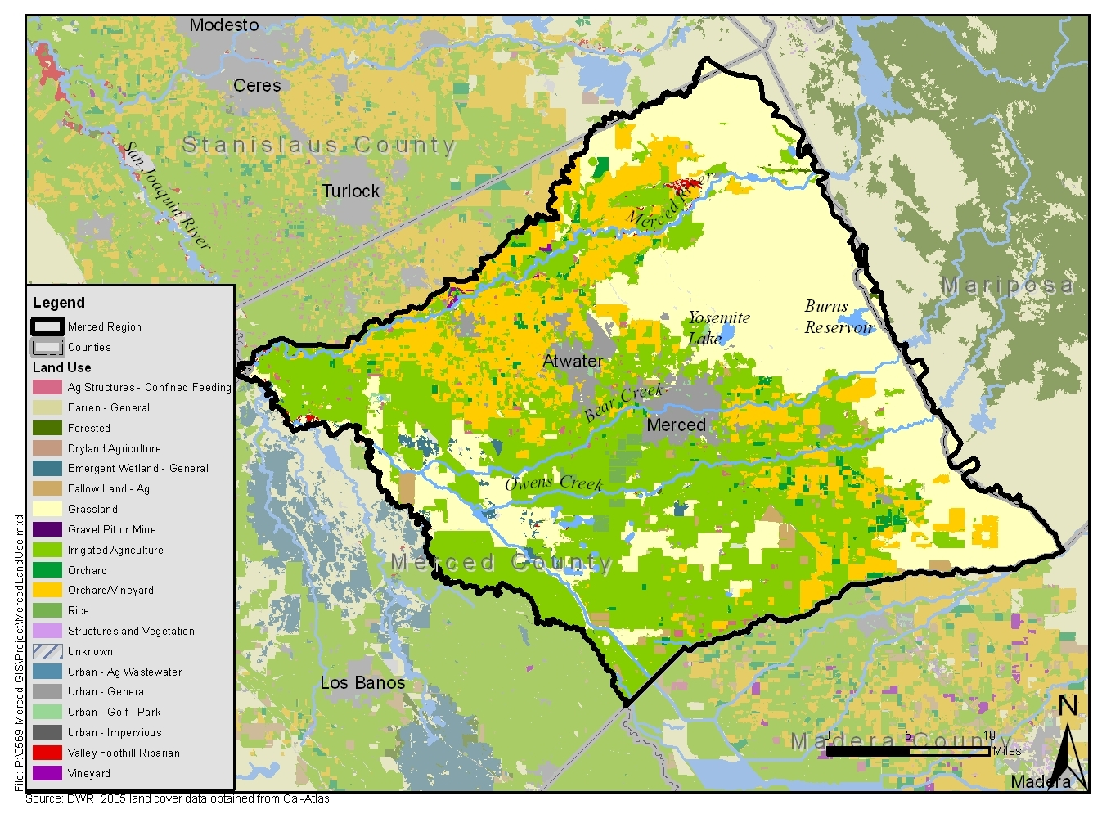
Figure 3: Future Land Uses in the Merced IRWM Region – TO BE DEVELOPED BASED ON GENERAL PLAN BUILDOUT LAND USE

The interconnected surface water and groundwater system in the Merced Region is complex, and water quality is directly and indirectly affected by land use practices throughout the watershed and subbasin. Stormwater drainage, precipitation-based sheet flow, agricultural drainage, wastewater effluent, and other contributing sources can dramatically affect surface water quality and quantity. Precipitation, irrigation, and recharge-based infiltration through variable surfaces and soil types in different land use settings also affect groundwater quality and quantity. In addition, groundwater accretions to surface waters have inter-related outcomes on both surface and ground water simultaneously. Manmade and natural conveyances, including but not limited to irrigation and flood management projects, have the potential to transfer water sources with significantly different characteristics throughout the proposed boundary. Public, domestic, irrigation and industrial production wells can create highly variable ground water flow patterns and cones of depression affecting groundwater elevations and regional flow directions temporally and spatially, ultimately affecting the quality and quantity of groundwater in the proposed boundary. Collectively, MAGPI and the Merced Region IRWM stakeholders represent a motivated and structured opportunity to integrate water management activities related to natural and manmade water systems, including water supply reliability, water quality, environmental stewardship, and flood management in the Merced Region.

Current Relationships Between Water Managers and Land Use Planners
There are 15 municipal and agricultural water purveyors within the region, several with statutory authority over water use:

- Black Rascal Water Company
- City of Atwater
- City of Livingston
- City of Merced
- Merced County (statutory authority only; not a municipal or agricultural purveyor)
- Le Grand Community Services District
- Le Grand-Athlone Water District
- Lone Tree Mutual Water Company
- Meadowbrook Water Company
- Merced Irrigation District
- Merquin County Water District
- Planada Community Services District
- Stevenson Water District
- Turner Island Water District
- Winton Water & Sanitary District
Four of these water purveyors also have local land use jurisdiction: the City of Atwater, City of Livingston, City of Merced, and Merced County. This allows for water planning activities to be an integral part of land use planning processes within these agencies’ jurisdictions. However, water infrastructure within Merced County is highly decentralized with over 25 irrigation and local special districts, as well as private companies serving relatively small areas. For the most part, the districts are independent entities created under California State Law, each governed by separate elected boards and managed by individual staff. The Merced County government does not have any jurisdiction over the districts and is not directly involved in water policy or management; therefore, linking water and land use planning can be challenging. Land use planning is addressed for each of the water and sanitary districts within the County in its General Plan (Mintier & Associates, 2007).

Future Efforts to Establish Proactive Relationships
The development of the Merced Region’s first IRWM Plan presents an excellent opportunity to help water planners and land use planners work together, identify efficiencies, foster communication, and integrate water management and land use planning. Currently, two of the three RWMG member agencies (the City of Merced and the County of Merced) also have local land use planning authority in the Region. In the future, it is possible that the City of Livingston and / or the City of Atwater, the remaining land use agencies in the region, may be considered for RWMG membership. Regardless of whether all land use agencies are members of the RWMG, the opportunity to discuss water management topics as they relate to land use planning will exist. As IRWM planning continues in the Region, it is envisioned that the following actions will be taken to enhance coordination and communication between water resources managers and land use planners.
- Targeted forums focused on land use planners and water resource managers will be held to improve understanding of the relationship between land use planning and water management. For example, meetings between water managers and land use planners will be arranged to discuss regional water issues and concerns and identify areas for enhanced collaboration. Ultimately these discussions are expected to generate multi-purpose IRWM projects that will assist the Region in meeting its objectives while maintaining consistency with local land use designations.
- Early consultation regarding land use decisions as suggested by the Ahwahnee Water Principles for Resource-Efficient Land Use will be encouraged. Nine community principles and five implementation measures were developed by leading water experts from the national, state, and local levels. These principles and measures address concerns about stormwater runoff, flood damage, and local water supply reliability for current residents and new development by identifying cost-saving stewardship actions that cities and counties can implement. The Merced Region believes all of the Ahwahnee Implementation Principles for Resource-Efficient Land Use should be applied, as appropriate:
- Water supply agencies should be consulted early in the land use decision-making process regarding technology, demographics and growth projections.
- City and county officials, the watershed council, LAFCO, special districts and other stakeholders sharing watersheds should collaborate to take advantage of the benefits and synergies of water resource planning at a watershed level.
- The best, multi-benefit and integrated strategies and projects should be identified and implemented before less integrated proposals, unless urgency demands otherwise.
- From start to finish, projects and programs should involve the public, build relationships, and increase the sharing of and access to information.
- Plans, programs, projects and policies should be monitored and evaluated to determine if the expected results are achieved and to improve future practices (Local Government Commission, 2012).
Implementing these actions will ultimately benefit the Region by fostering:
- Enhanced understanding of water supply and water quality impacts associated with land use planning decisions;
- Improved representation of water-related needs and regional objectives related to land use planning; and
- Identification of IRWM projects and programs that address regional objectives as well as local land use planning goals.
As previously described, the Merced Region IRWM planning process will provide the region’s water and land use planner with an established forum to engage in discussion regarding water management issues and land use plans. The RWMG meetings will provide an interface for the water and land use managers to express concerns and propose solutions. In the future, should a more robust and detailed approach be needed to further establish relationships between land use and water planners, some or all of the options previously described may be implemented.

References
Mintier & Associates. 2007. Merced County General Plan, Public Review Draft Background Report. June 21, 2007.
Quad Knopf. 2011. Final Program Environmental Impact Report, City of Merced Vision 2030 General Plan. July 2011.
PMC. 2008. City of Livingston 2025 General Plan. October 2008.
Local Government Commission 2012. Ahwahnee Water Principles. May 21, 2012. <http://www.lgc.org/ahwahnee/h2o_principles.html>.

